What is it like in the Alps? Spring Term 1 2025 |  |  |  | Year 6
English  Narrative  - Know how to describe a setting using a range of descriptive language.  - Know how to use correct punctuation and grammar for speech, using dialogue to advance the action.  - Know how to use tenses consistently and how to vary them for effect.  - Know how to vary the use of sentence types and punctuate accordingly. | Science  Living Things and their Habitats  - Know how to classify living organisms.  - Know the kingdoms of life.  - Know how to classify living things using the Linnaean system.  - Know the characteristics of different types of microorganisms.  - Know how to investigate asexual reproduction through spore dispersal.  - Know how to classify and describe a living organism. | 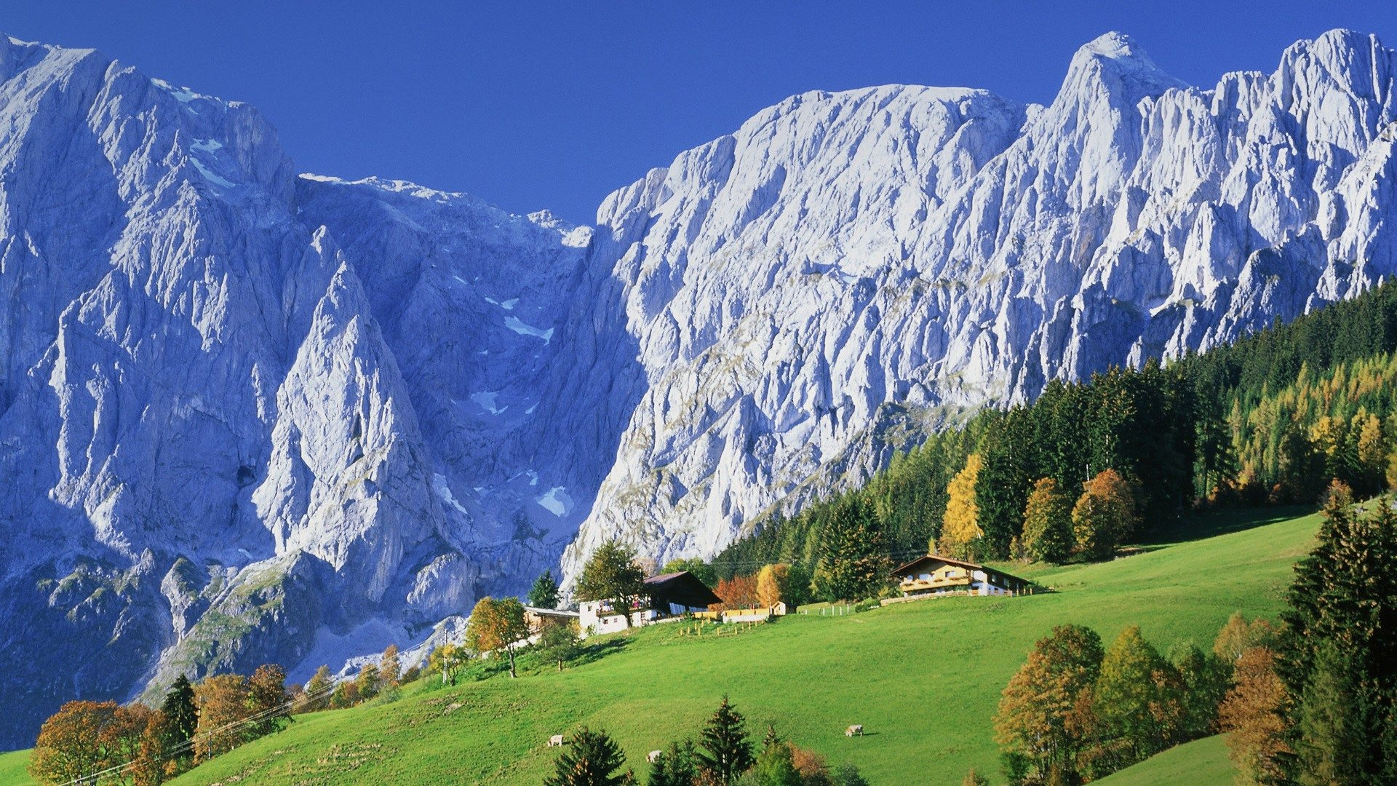  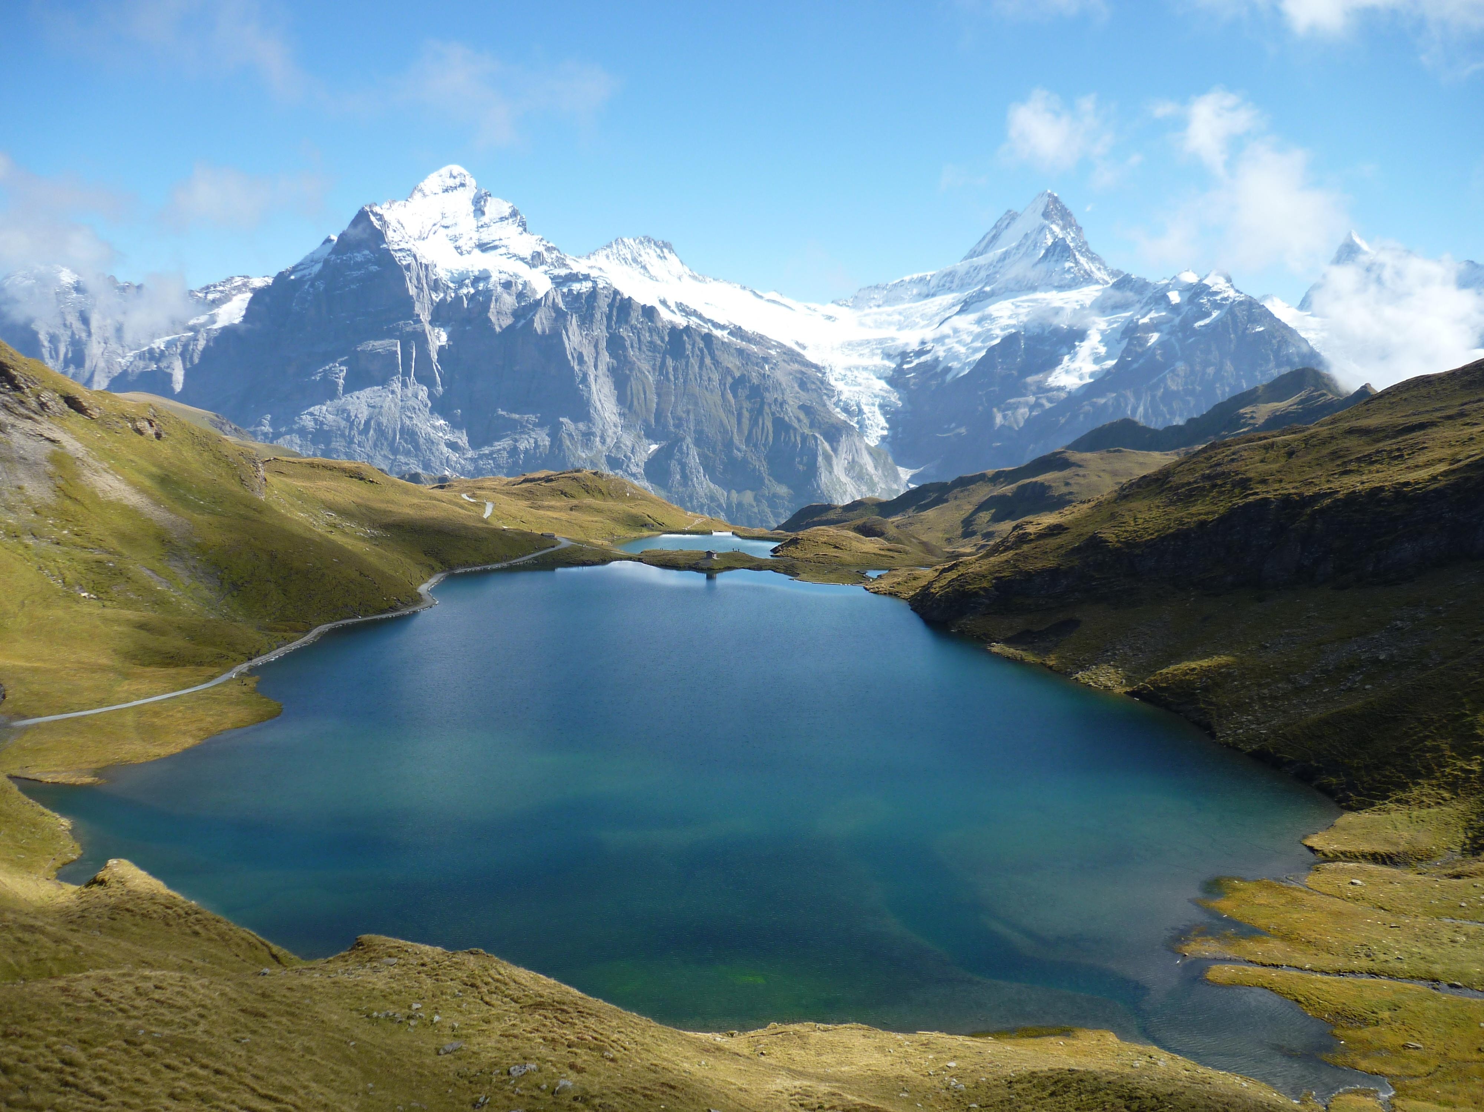  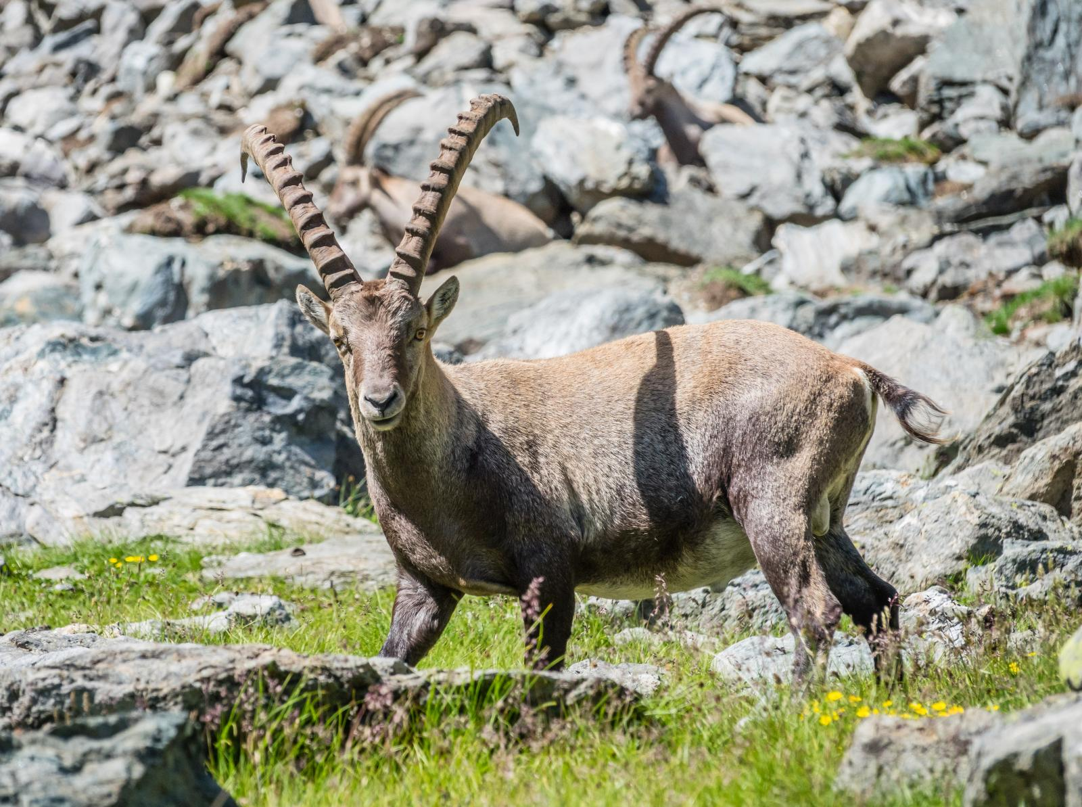  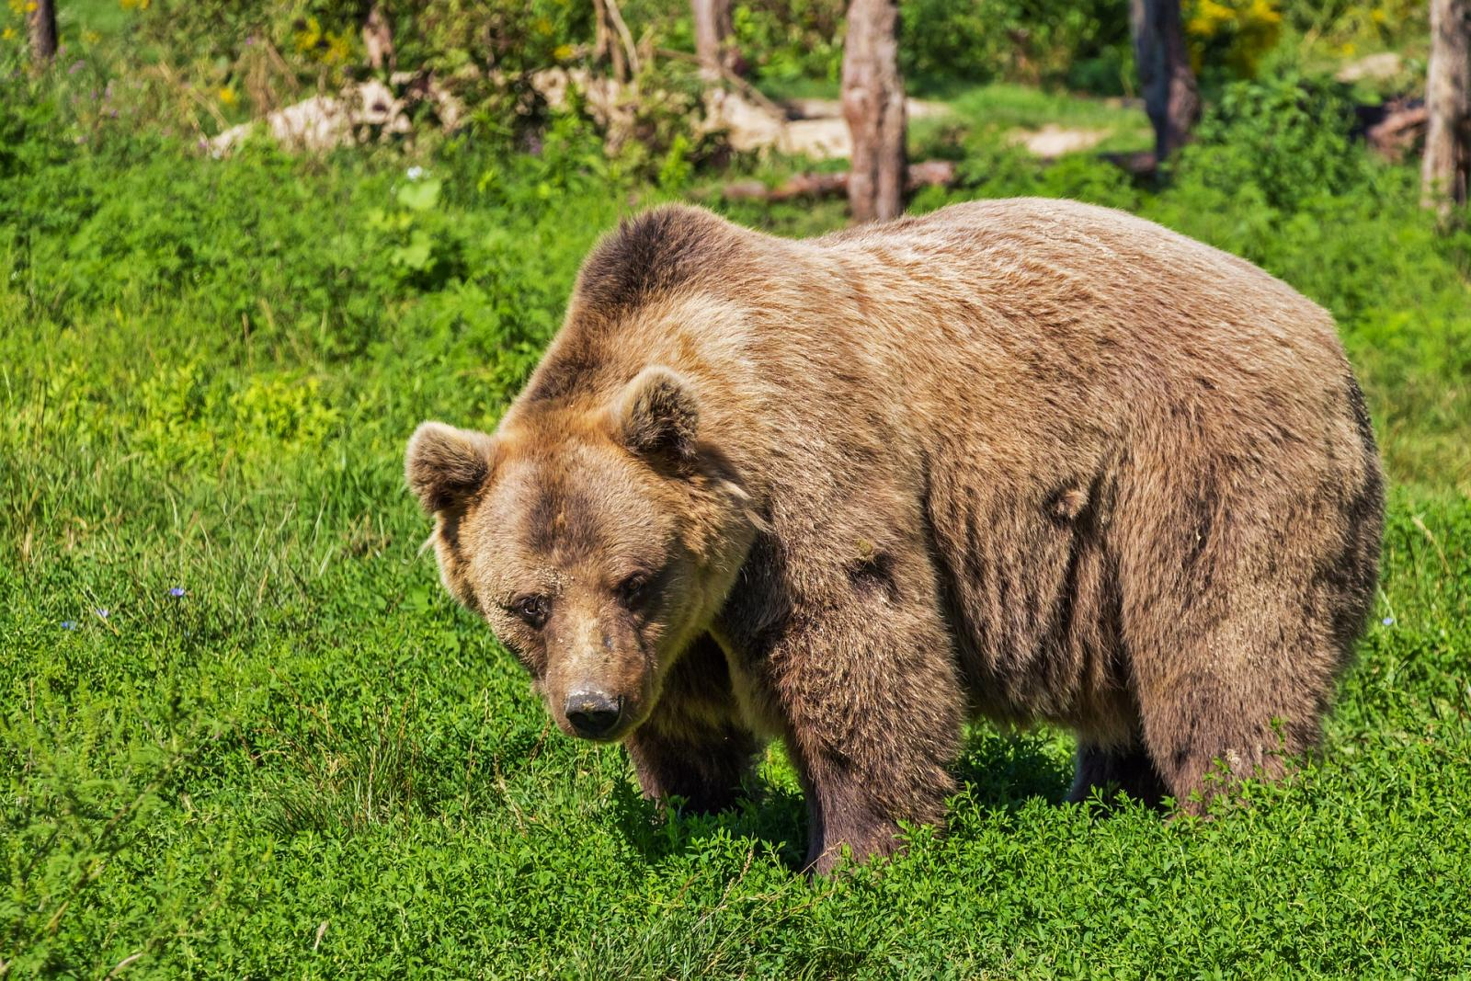 | Geography  - Know how to locate the Alps on a map.  - Know how to locate the key physical and human characteristics of the Alps.  - Know how to describe the physical and human features of an Alpine region.  - Know what there is to do in Saltash using data collection.  - Know similarities and differences between Saltash and an Alpine area.  Know the human and physical geography of the Alps. | P.S.H.E.  Dreams and Goals  - Know my learning strengths and can set challenging but realistic goals for myself.  - Know how to work out the learning steps I need to take to reach my goal and understand how to motivate myself to work on these.  - Know how to identify problems in the world that concern me and talk to other people about them.  - Know how to work with other people to make the world a better place.  - Know some ways in which I can work with the other people to help make the world a better place.  - Know what some people in my class like or admire about me and can accept their praise.
Key Vocab:  onomatopoeia, simile, metaphor, personification, alliteration, adjectives, prepositions, adverbs, adverbials, nouns, verbs, tenses, dialogue, inverted commas | Key Vocab:  Classification, fungi, prokaryotes, Protoctista, amoeba, bacteria, category, taxonomy, morphology, genetics, biochemistry, species, mould, microorganisms, asexual reproduction |  | Key Vocab:  Atlas, climate, coniferous, deciduous, hemisphere, latitude, longitude, temperate, vegetation, tourism, population, sea level | Key Vocab:  Goals, dreams, aspirations, motivation, compliments, culture, issues, cooperation
Art/D.T.  DT  Textiles:  - Know how to design a stuffed toy.  - Know how to sew a blanket stitch.  - Know how to create and add decorations to a fabric.  - Know how to use blanket stitch to assemble the components of a stuffed toy. | Computing  Programming a Variables in Games  - Know that a ‘variable’ is something that is changeable.  - Know why a variable is used in a program.  - Know how to improve a game by using variables.  - Know how to design a project that builds on a given example.  - Know how to use my design to create a project.  - Know how to evaluate my project. | Music  Charanga: A New Year Carol  - Know a song from memory, who sang them and when they were written.  - Know some style indicators of the song.  - Know the names of some instruments found in the song.  - Know music dimensions for the song.  - Know how to recognise connection between sounds and symbols.  - Know how to perform with confidence. | R.E.  Creation Vs Science: Complimentary or Conflicting  - Know what type of text some Christians say Genesis 1 is, and its purpose.  - Know how Christians might interpret Genesis 1 in different ways.  - Know how to make connections between Genesis 1 and Christian belief about God as Creator.  - Know why many Christians find science and faith go together.  - Know key ideas arising from Genesis 1.  - Know how to justify my views regarding Creation. | French  At the weekend  - Know how to ask what the time is in French.  - Know how to tell the time accurately, including quarter past, half past and quarter to.  - Know a range of phrases in French to talk about the activities that I do at the weekend and can remember at least half by heart.  - Know how to identify the verb in these sentences.  Know how to give an account of what I do at the weekend and at what time.
Key Vocab:  Accurate, annotate, appendage, blanket-stitch, design criteria, stuffing, detail, evaluate, fabric, assemble, component | Key Vocab:  Program, variable, algorithm, evaluate, experiment, concept, feedback, design, feature, criteria, improve | Key Vocab:  dynamics, verse, chorus, texture, tempo, rhythm, pitch, pulse, timbre, notation, structure | Key Vocab:  Genesis 1, creation, conflict, compliment, poem, prayer, viewpoint, cosmology, evolution, Literalists, Conservatives, Liberals | Key Vocab:  (See vocab list in books)

