How was school different in the past? Spring Term 1 2025 |  |  |  | Year 1
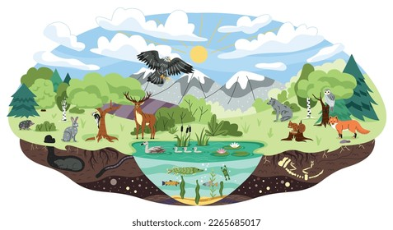  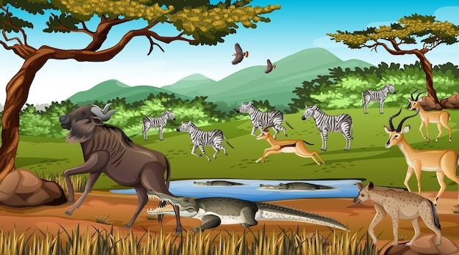  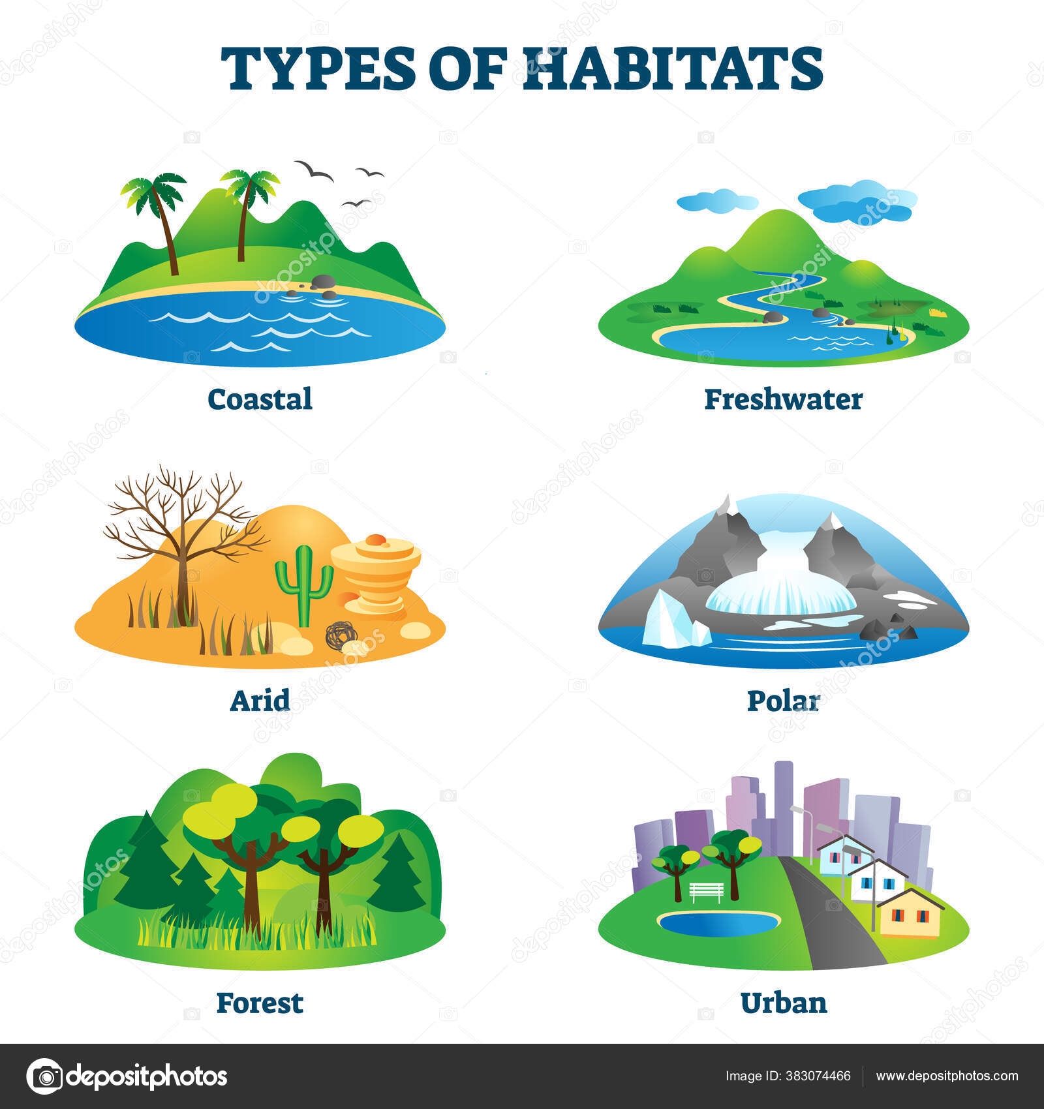 | Science  Living things and their habitats  Know some plants that would have existed during the time of dinosaurs.  Know and name a variety of common animals including fish, amphibians, reptiles, birds and mammals.  Know and recognise similarities between dinosaurs and animals today.  Know and name some animals which are carnivores, herbivories and omnivores.  Know the structure of some common animals.  Know the terms predator and prey and what these means.  Know the difference between things which are living, dead and things that have not been alive.  Know that most living things live in habitats which they are suited to.  Know how different habitats suit the basic needs of animals and plants.  Know the season of spring and understand changes which occur.  Know how to work scientifically. | 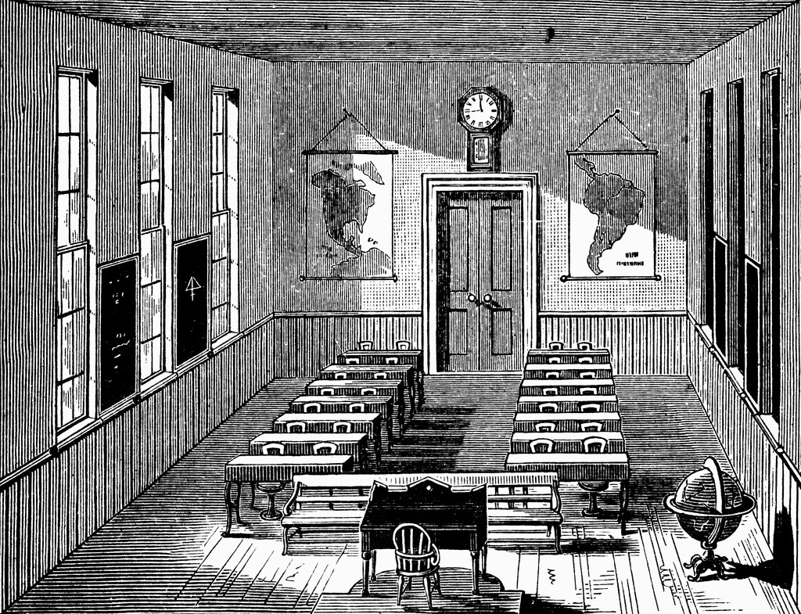  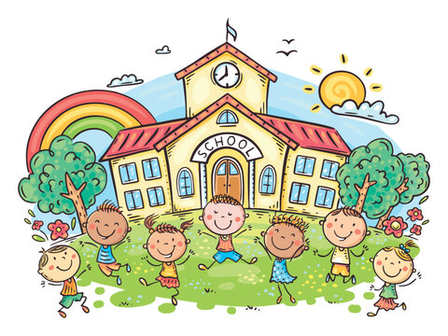  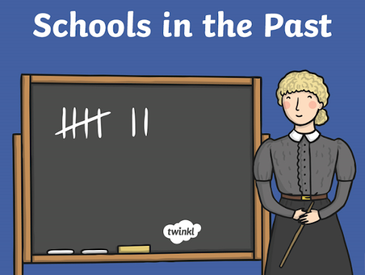 | History  How was school different in the past?  Know how to correctly order and date four photographs on a timeline and add some dates.  Know how to ask questions about schools in the past.  Know how to make one comparison between schools in the past and present.  Know how to use sources to research and develop an understanding of what schools were like 100 years ago.  Know how to identify three features of a classroom now and a classroom 100 years ago, identifying some similarities and differences.  Know how to recognise two similarities and two differences between schools now and schools in the past.  Know how to state whether they would have preferred to go to school in the past or not and explain why. | P.S.H.E.  Dreams and Goals  Know how to choose a realistic goal and think about to achieve it.  Know what persevering means.  Know strategies of how to persevere  Know how working with others can be beneficial.  Know how to share success with other people.
 | Key Vocab:  Animals, humans, fish, mammals, reptiles, birds, amphibians, carnivore, herbivore, omnivore, predator, prey, habitats, fossils |  | past timeline date different decade present important similar modern living memory evidence source decade beyond living memory preferred | Key Vocab:  Goals, persevering, choices, empathy, stressed, healthy, relaxed, collaboration
Art/D.T.  Mechanisms – making a moving story book  Know whether a mechanism is a side-to-side slider or an up-and-down slider and determine what movement the mechanism will make.  Know how to label drawings to show which parts of their design will move and in which direction.  Know how to make a picture that meets the design criteria, with parts that move purposefully as planned.  Evaluate the main strengths and weaknesses of their design and suggest alterations. | Computing  Moving a robot  Know what a given command will do.  Know how to act out a given word.  Know how to follow and give instructions.  Know how to combine ‘forwards’ and ‘backwards’ commands to make a sequence.  Know how to plan a simple program.  Know how to find solutions to a problem. | Music  ‘In the Groove’  Know that music can be in different styles such as Blues, Baroque, Latin, Irish Folk and Funk.Know how to find the pulse to different music.Know how to clap a rhythm to a piece of music. Know how to sing in different styles.Know how to compose a simple melody using simple rhythms, choosing from the notes C+D or  C, D + E. Know how to perform and share to others. | R.E.  Christianity  What is the good news Christians believe Jesus brings?  Know that Christians believe that Jesus brings good news.  Know some stories from the bible.  Know what different bible stories mean to Christians.  Know that Christians believe that Jesus gives instructions to people about how to behave. | PE  Dance  Know how to explore movement ideas.  Know how to move confidently and safely.  Know how to explore a range of actions with coordination and control.  Know how to compose and perform a dance that communicate moods, ideas and feelings.  Know the importance of warming up and cooling down.
Key Vocab:  - assemble  - mechanism  - sliders | Key Vocab:  information technology, robot, command, forwards, backwards, sequence, program, solution, objects, label, properties, record, data | Key Vocab:  rhythm, pulse, sing, music, sound, pitch, low, high, listen, loud, quiet, fast, slow, steady beat, tempo | Key Vocab:  gospel, disciples, New Testament, forgiveness, peace, | Key Vocab:  position, coordination, control, mood, feelings, actions

