Meet Mrs Grinsted

I live at home with my husband and two children called Charlie and Nieve. They are both teenagers - 13 and 14. We really like to go kayaking together.

My favourite place is the beach. Being near the sea makes me happy and I really enjoy body boarding and paddle boarding.

I love being a primary school teacher! I have been doing this job for 20 years and always enjoy meeting and working with new children. My favourite time of the year is September when I get to meet my new class and learn lots about them.

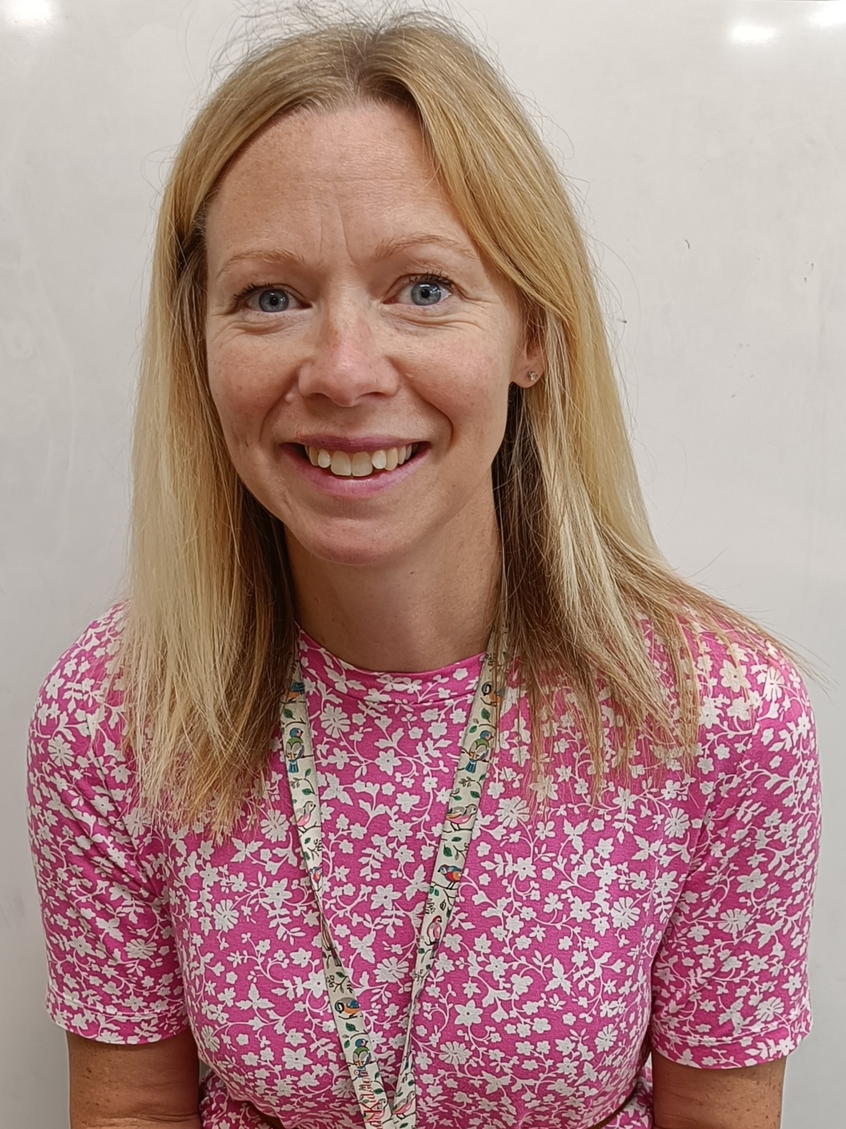

Me and my daughter like to go ice skating and roller skating. We love learning new tricks and going as fast as we can!

I absolutely love reading. My best way to relax is to curl up with a good book. I love reading books to my class too – how many books can we read together this year?

I really love dogs. I have two dogs at home called Poppy and Teddy. Poppy is a Havenese – she is small, white and fluffy. Teddy is an Italian Greyhound. He is dark brown and very fast!